Application Architecture Document

1. Overview
This document outlines the application architecture for Ti Tans Bank’s digital banking platform, covering frontend, backend services, data storage, third-party integrations, and security.

Architecture Diagram
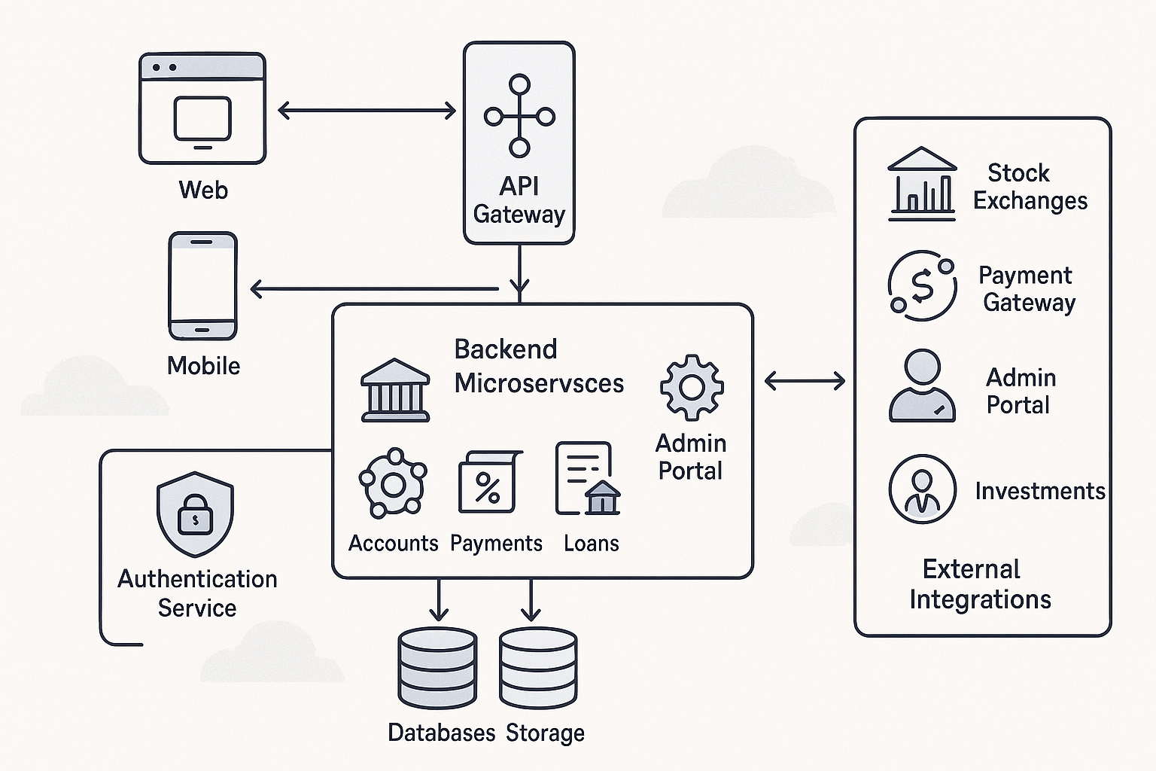

2. Architecture Components

Frontend
- Web Frontend: Browser-based interface for customers to access banking services.
- Mobile App: Native mobile applications (iOS/Android) for on-the-go banking.

API Gateway
- Central entry point for all client requests, routing them to appropriate backend services.
- Handles rate limiting, authentication forwarding, and logging.

Backend Services
- Authentication Service: Manages login, MFA, session tokens.
- Account Management: Handles user profiles, account creation, and updates.
- Transaction Service: Processes fund transfers, payments, and transaction history.
- Investment Service: Manages mutual funds, stock portfolios, and market data.
- Loan Service: Handles loan applications, eligibility checks, and EMI tracking.

Database Layer
- Centralized relational and NoSQL databases for storing user data, transactions, and logs.

Security & Compliance
- Encryption modules (256-bit), fraud detection, audit logging, and compliance with RBI, GDPR.

Third-Party Integrations
- Payment gateways, stock exchange APIs, credit bureaus.

External Services
- Real-time services for payments, stock prices, and credit scoring.

3. Component Interactions
Clients interact via Web or Mobile, routed through the API Gateway. The gateway forwards requests to backend services, which interact with the database and external services. Security and compliance modules monitor and secure all layers.

4. Deployment Considerations
- Microservices architecture deployed via containers (e.g., Docker, Kubernetes)
- Load balancers for frontend and API Gateway
- Auto-scaling and failover mechanisms
- Secure communication via HTTPS and VPN tunnels for third-party APIs

